Using HTTP.sys and the WWW service architecture provides the following benefits:

* When a worker process fails, service is not interrupted; the failure is undetectable by the user because the kernel queues the requests while the WWW service starts a new worker process for that application pool.
* Requests are processed faster because they are routed directly from the kernel to the appropriate user-mode worker process instead of being routed between two user-mode processes.

HTTP.sys provides the following services in IIS 6.0:

* Routing HTTP requests to the correct request queue.
* Caching of responses in kernel mode.
* Performing all text-based logging for the WWW service.
* Implementing Quality of Service (QoS) functionality, which includes connection limits, connection timeouts, queue-length limits, and bandwidth throttling.

# IIS ADMINISTRATION Scripts

|  |  |  |
| --- | --- | --- |
| IIS Area/Component | Script | Tasks |
| Web sites | Iisweb.vbs | *Create, delete, start, stop, pause, and query or list Web sites.* |
| FTP sites | Iisftp.vbs | *Create, delete, start, stop, pause, and query or list FTP sites. Query and set Active Directory properties for a users FTP home directory (use in FTP user isolation).* |
| Web virtual directories | Iisvdir.vbs | *Create, delete, or list the Web virtual directories of a given root.* |
| FTP virtual directories | Iisftpdr.vbs | *Create, delete, or list the FTP virtual directories of a given root.* |
| Back up and restore IIS configuration | iisback.vbs | *Create, delete, restore, and list backup copies of IIS configuration.* |
| Export or import IIS configuration | Iiscnfg.vbs | *Export or import an IIS configuration to or from an XML file; copy the metabase and schema to another computer; and save configuration changes to disk.* |
| Applications and dynamic content services | Iisext.vbs | *Configure and manage applications, Web service extensions (like ASP and ASP.NET), and individual files.* |
| Application pools and their worker processes | Iisapp.vbs | *List the worker processes (W3wp.exe) currently running and the application pool each one serves.* |

# Useful Weblinks

## Microsfot IIS 6.0 Documentation:

<http://technet.microsoft.com/en-us/library/cc775635(WS.10).aspx>

## Official Microsoft IIS Site:

<http://www.iis.net/>

|  |  |  |
| --- | --- | --- |
| gerry.hounsell@live.co.ukDate Printed: 26 June 2021 | | Revision 1.1 |
| [Windows Server System](http://www.microsoft.com/windowsserversystem/default.mspx) | IIS 6.0 Architecture Cribsheet | | |

# IIS Core Components

HTTP Protocol Stack (HTTP.sys). How the HTTP protocol stack protects the operating system kernel from the effects of imperfect application code, and how it handles kernel-mode queuing.

Worker processes. How the worker process is controlled by the WWW service in both application isolation modes, but in different ways.

WWW Service Administration and Monitoring. How the WWW Service Administration and Monitoring component manages the lifetime of the worker process.

Inetinfo.exe. How the role of Inetinfo.exe has changed since IIS 5.0.

IIS Metabase. Benefits of the new XML metabase, especially in diagnosing possible metabase corruption or in reading and editing the metabase configuration.

# IIS Services

|  |  |  |  |  |
| --- | --- | --- | --- | --- |
| Service | | Description | Core Component | Host |
| Name | Short  Name |
| World Wide Web Publishing Service (WWW service) | W3SVC | Delivers Web publishing services. | Iisw3adm.dll | Svchost.exe |
| File Transfer Protocol (FTP) | MSFTPSVC | Allows file uploads and downloads from remote systems. | Ftpsvc2.dll | Inetinfo.exe |
| Simple Mail Transfer Protocol (SMTP) | SMTPSVC | Sends and receives electronic messages (e-mail). | Smtpsvc.dll | Inetinfo.exe |
| Network News Transfer Protocol (NNTP) | NNTPSVC | Distributes network news messages. | Nntpsvc.dll | Inetinfo.exe |
| IIS Admin Service | IISADMIN | Manages the metabase. | Iisadmin.dll | Inetinfo.exe |

# Request Processing Models

IIS 6.0 runs a server in one of two distinct request processing models, called application isolation modes. In each isolation mode, IIS functions differently, although both application isolation modes rely on HTTP.sys as the HTTP listener.

## Worker Process Isolation Mode

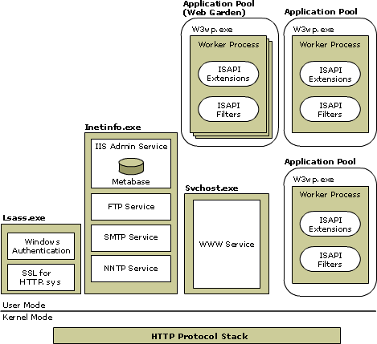

## IIS 5.0 Isolation Mode

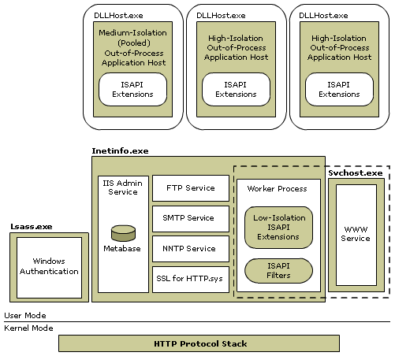

## Worker process isolation mode

Worker process isolation mode takes advantage of the redesigned architecture for IIS 6.0. In this application isolation mode, Web applications are grouped into application pools, through specific configuration settings can be applied to groups of applications and to the worker processes servicing those applications. By using application pools, all application code can be run in an isolated environment; however, unlike earlier versions of IIS, IIS 6.0 provides isolation without a performance penalty, because there are no added process hops. Worker process isolation mode provides application (or site) compatibility for most existing applications. This application isolation mode is specified by a false value for the metabase property IIs5IsolationModeEnabled.

## IIS 5.0 isolation mode

IIS 5.0 isolation mode is provided for applications that depend upon specific features and behaviors of IIS 5.0. Use this mode only if an application has a compatibility issue when it runs in worker process isolation mode and you cannot resolve the problem.

In this application isolation mode, you can isolate applications as you did in IIS 5.0: in Low isolation (in-process), Medium isolation (pooled out-of-process), or High isolation (out-of-process). This application isolation mode is specified by a true value for the IIs5IsolationModeEnabled metabase property.

# IIS Metabase

## Metabase Elements

IIS 6.0 replaces the single binary file (MetaBase.bin) of earlier IIS versions with two XML files: **MetaBase.xml** and **MBSchema.xml**.

IIS stores these files in the **systemroot\System32\Inetsrv** folder of your computer. To view and modify these files, you must be a member of the Administrators group.

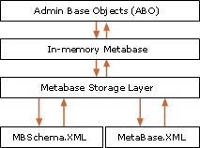The metabase consists of the following elements:

* **MetaBase.xml** file. This file stores IIS configuration information that is specific to an installation of IIS.
* **MBSchema.xml** file. This file contains the metabase schema. The MBSchema.xml file is a master configuration file that defines default attributes for all metabase properties and enforces rules for constructing and placing metabase entries within the metabase.
* **In-memory metabase**. The in-memory metabase contains the most current metabase and metabase schema configuration. The in-memory metabase accepts changes to the metabase configuration and schema, storing them in RAM, and periodically writing changes to the on-disk metabase and metabase schema files.

# IIS HTTP Protocol Stack

By using HTTP.sys to process requests, IIS 6.0 delivers the following performance enhancements:

* Kernel-mode caching. Requests for cached responses are served without switching to user mode.
* Kernel-mode request queuing. Requests cause less overhead in context switching, because the kernel forwards requests directly to the correct worker process. If no worker process is available to accept a request, the kernel-mode request queue holds the request until a worker process picks it up.